International Jubilee

Private School
2017 – 2018 School Supply List (Grade3)
- 4 A4 Notebook (as Portfolio) 100 pages (Non – Wired)
- 1 A4 Notebook (as Portfolio) 120 pages (Non – Wired)
- 2 Normal Notebooks 80 pages (1 Line, Non – Wired)
- 1Plastic File
- 5 glue sticks
- 1 scale (30 cm – Plastic)
- 2 pack sticky notes
- 1 4 – oz bottle school glue
- 2 large boxes of facial tissue (do not label for 1 Term)
- Antibacterial wipes.(All the time with the student)
- Hand Sanitizer. (All the time with the student)
- 2 packs of Pleistocene.صلصال
- 1 box sandwich – sized zipper bags (do not label)
- 1 pack A4 colored Paper(do not label)
- 1 Pack A4 White paper(do not label
- White board Markers and eraser (Dry erase)
please note
- Label all supplies (except those marked as do not label) with student’s name using permanent marker.
- Send supplies in, on the first day of school.
- Specialists may require additional school supplies after school begins.

الرجاء إرسال هذه الأدوات في أول يوم للدراسة وشكرا لتعاونكم.
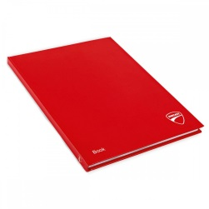
A4 Portfolio

International Jubilee

Private School
2017 – 2018 School Supply List (Grade3)
- 4 bA4 Notebook (as Portfolio) 100 pages (Non – Wired)
- 1 A4 Notebook (as Portfolio) 120 pages (Non – Wired)
- 2 Normal Notebooks 80 pages (1 Line, Non – Wired)
- 1 Plastic File
- 5 glue sticks
- 1 scale (30 cm – Plastic)
- 2 pack sticky notes
- 1 4 – oz bottle school glue
- 2 large boxes of facial tissue (do not label for 1 Term)
- Antibacterial wipes.(All the time with the student)
- Hand Sanitizer. (All the time with the student)
- 2 packs of Pleistocene.صلصال
- 1 box sandwich – sized zipper bags (do not label)
- 1 pack A4 colored Paper(do not label)
- 1 Pack A4 White paper(do not label
- White board Markers and eraser (Dry erase)
please note
- Label all supplies (except those marked as do not label) with student’s name using permanent marker.
- Send supplies in, on the first day of school.
- Specialists may require additional school supplies after school begins.

الرجاء إرسال هذه الأدوات في أول يوم للدراسة وشكرا لتعاونكم.
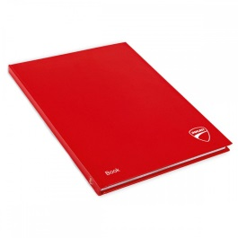
A4 Portfolio

