International Jubilee Private School

2017-2018 School Supply List
Grade 2
4 A4Notebook(as portfolio) 100papers maximum (Non-Wired).
1 A4 Notebook 120 papers maximum (Non-Wired). (Arabic)
2 Normal Notebooks 80 papers each.
- 1 plastic File
- 2 Erasers.
- 6 small glue sticks
- 1 4-oz bottle school glue
- 1 box of 24 crayons
- 2 large boxes facial tissue (do not label for 1 Term)
- Antibacterial wipes.(All the time with the student)
- Hand Sanitizer. (All the time with the student)
- 2 packs of Pleistocene.صلصال
- 1 box sandwich-sized zipper bags (do not label)
- 1 pack A4 colored Paper(do not label)
- 1 Pack A4 White paper(do not label)
- Pencils (a packet )
- 2 Sharpeners
- White board markers
- White board eraser
- 2 packs of Sticky Notes.

please note
- Label all supplies (except those marked as do not label) with student’s name in permanent marker.
- Send supplies in on the first day of school.
- Specialists may require additional school supplies after school begins.

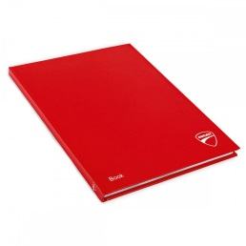
A4 Portfolio

International Jubilee Private School

2017-2018 School Supply List
Grade 2
4 A4 Notebook (as portfolio) 100 papers maximum (Non-Wired).
1 A4 Notebook 120 papers maximum (Non-Wired). (Arabic)
2 Normal Notebooks 80 papers each.
- 1 plastic File
- 2 Erasers.
- 6 small glue sticks
- 1 4-oz bottle school glue
- 1 box of 24 crayons
- 2 large boxes facial tissue (do not label for 1 Term)
- Antibacterial wipes.(All the time with the student)
- Hand Sanitizer. (All the time with the student)
- 2 packs of Pleistocene.صلصال
- 1 box sandwich-sized zipper bags (do not label)
- 1 pack A4 colored Paper(do not label)
- 1 Pack A4 White paper(do not label)
- Pencils (a packet )
- 2 Sharpeners
- White board markers
- White board eraser
- 2 packs of Sticky Notes.

please note
- Label all supplies (except those marked as do not label) with student’s name in permanent marker.
- Send supplies in on the first day of school.
- Specialists may require additional school supplies after school begins.

A4 Portfolio

