International Jubilee Private School

2017-2018 School Supply List
Grade 1

5 A4 Notebook (As Portfolio)100 papers (Non-Wired).
- 1 plastic File
- 12 # 3 pencils
- 3 Erasers and sharpeners.
- 6 small glue sticks
- 1 4-oz bottle school glue
- 1 box of 24 crayons
- Antibacterial wipes.(All the time with the student)
- Hand Sanitizer. (All the time with the student)
- 3 Antibacterial wipes.
- 1 packs of Pleistocene.صلصال
- 1 box sandwich-sized zipper bags (do not label)
- 1 pack A4 colored Paper(do not label)
- 1 Pack A4 White paper(do not label
- 3 large box facial tissue (do not label
- One box (6 colors) poster paint and brush
- 1 mini white board with eraser (labelled)
- 1 pack of white board markers (labelled)
- 1 pack of paper plates (1 big and 1 small size)
please note
- Label all supplies (except those marked as do not label) with student’s name in permanent marker.
- Send supplies in on the first day of school.
- Specialists may require additional school supplies after school begins.
- الرجاء إرسال هذه الأدوات في أول يوم للدراسة وشكرا لتعاونكم.
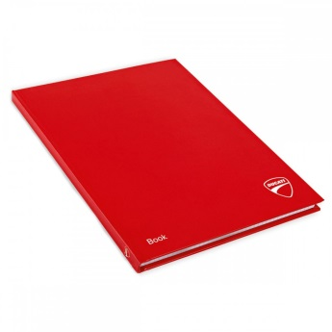
A4 Portfolio

International Jubilee Private School

2017-2018 School Supply List
Grade 1

5 A4 Notebook (As Portfolio)100 papers (Non-Wired).
- 1 plastic File
- 12 # 3 pencils
- 3 Erasers and sharpeners.
- 6 small glue sticks
- 1 4-oz bottle school glue
- 1 box of 24 crayons
- Antibacterial wipes.(All the time with the student)
- Hand Sanitizer. (All the time with the student)
- 3 Antibacterial wipes.
- 1 packs of Pleistocene.صلصال
- 1 box sandwich-sized zipper bags (do not label)
- 1 pack A4 colored Paper(do not label)
- 1 Pack A4 White paper(do not label
- 3 large box facial tissue (do not label
- One box (6 colors) poster paint and brush
- 1 mini white board with eraser (labelled)
- 1 pack of white board markers (labelled)
- 1 pack of paper plates (1 big and 1 small size)
please note
- Label all supplies (except those marked as do not label) with student’s name in permanent marker.
- Send supplies in on the first day of school.
- Specialists may require additional school supplies after school begins.
- الرجاء إرسال هذه الأدوات في أول يوم للدراسة وشكرا لتعاونكم.
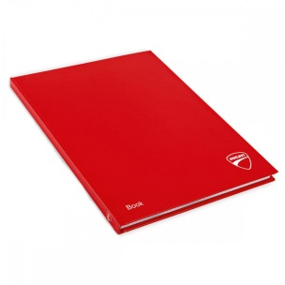
A4 Portfolio

