Uniform Policy
All students must come in proper uniform. The rules are given below:
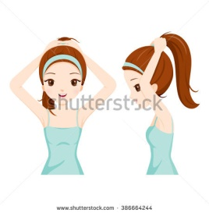
Boys:
- Must wear the correct uniform with school emblem.
- Sweaters or sweat shirts with the school logo.
- Black leather formal shoes and white socks.
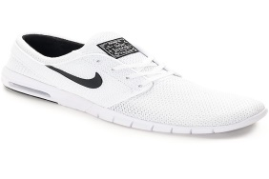
- PE uniforms according to the schedule with Sports shoe.
- Boys must come to school in Army cut only.
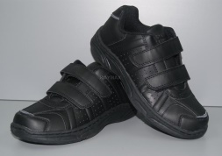
Girls:
- Must wear the correct uniform with school emblem.
- Sweaters or sweat shirts with the school logo.
- Black leather formal shoes and white socks.
- PE uniforms according to the schedule with Sports shoe.
- Hair must be neatly tied with Black or White Hair band.

Note:
GIRLS ARE NOT SUPPOSED TO USE HAIR COLOR, COSMETICS, NAIL COLORM AND JEWELLERY.

I read and rules and regulations of the school uniform. I hereby agree that my child will come in proper uniform to school.

Agree: Disagree:
Name of the parent\guardian: ----------------------------------------- Signature: --------------------------
Name of the child: -------------------------------------------------------- Class & Div.: -----------------------

