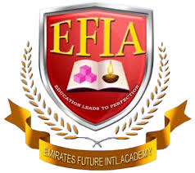

EMIRATES FUTURE INTERNATIONAL ACADEMY
“You are off to great places, Today is your day!! Your mountain is waiting so get on your way”
EFIA
Cordially invites all KG parents to the
KG ORIENTATION PROGRAMME
for the academic year
2018-19
On Saturday, 3rd March 2018
At 9.00 am
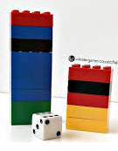
In the Main Auditorium, EFIA CAMPUS
