**EMIRATES FUTURE INTERNATIONAL ACADEMY**

**KINDERGARTEN SECTION**

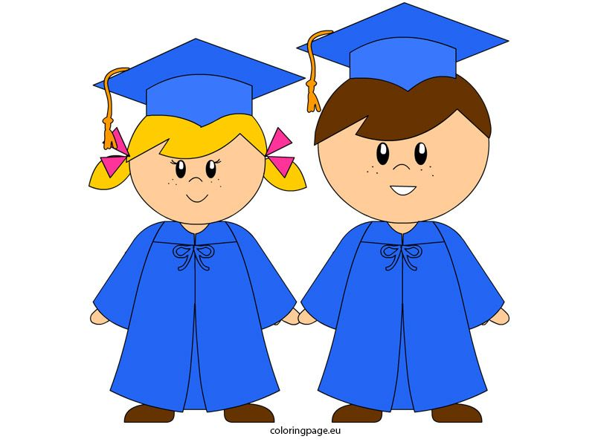**SENIOR KG GRADUATION CEREMONY: 2022**

|  |  |  |
| --- | --- | --- |
| **Date –22nd ,March, 2022**  **REF: EFIA KG/CIR-67/2021-22** |  |  |

Dear Parents,

We are glad to inform you that our school, **Emirates Future International Academy** is celebrating the **Graduation Ceremony for the students of KG2**, at our school premises, on **Thursday, 24th March, 2022 at 9 am onwards.**

**LIVE STREAMING OF GRADUATION PROGRAMME:**

Due to COVID 19 protocol we are unable to accommodate parents in our campus. For parents to watch the function we will be live streaming the graduation programme on EFIA Facebook page. Link will be shared through Whatsapp and Google classroom. The invitation for parents will be uploaded on the school portal. All parents are invited to watch the programme through the Facebook page.

**TRANSPORTATION OF PHYSCAL SCHOOLING STUDENTS:**

Students who are using the school transport will be picked as usual and dropped back after the function .Kindly contact the bus coordinators for the timing.

**INSTRUCTIONS FOR DISTANCE LEARNING STUDENTS:**

Parents of Distance learning students are requested to make their own arrangements to drop their wards to school before the event (between 7.45 am to 8.00 am) and pick them back after the event at 12.10 AM. Transport facility will not be provided for the distance learning students. Send your child in neat and clean regular school uniform and with neatly groomed hair with snacks and water bottle.

**All the students of distance learning must submit 96 hours Negative PCR report to the class teacher on 23-03-2022 to attend the school on 23rd and 24th March.**

**PHOTO GRAPH & VIDEO**

Parents who required copy of the video and photography may kindly inform the class teacher and amount will be informed later.



Thanking you,

Regards

**Saji Oommen**

**Principal**