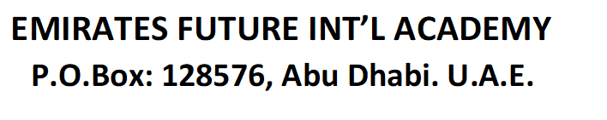
Ref: EFIA/ CIR- 22/ 2022-23 3/6/2022
Dear Parent,
We are pleased to inform you that Extramarks in collaboration with the schools in the Middle East, is offering rewards and recognition to meritorious students through an online Olympiad Test. Extramarks Olympiad Test is one of the Middle East and India’s biggest student recognition programs. Our school has been invited to participate in the Extramarks Olympiad Test 2022.
All students from grades III to XII can register for the Extramarks Olympiad Test FREE OF COST. Parents/students are required to fill and submit the online registration form using the link given below. Each participating student will receive a login username and password to log in and attempt the online Olympiad Test on the designated date and time.
Registration Link for Extramarks Olympiad 2022:
https://www.surveymonkey.com/r/WJKYRVZ
TEST DATE : Sunday 12th June 2022
TEST PATTERN: The Extramarks Olympiad Test is conducted on a similar syllabus taught at school. No additional reference books are required for the preparation of this test. Students are only required to be clear with all the concepts and basics. The questions asked in the Olympiad test require the students to have a wide thought process to solve a variety of problems based on logic and concepts. The test improves the students’ problem-solving ability and challenges them to think analytically and also provides exposure to the students on national as well as international platforms.
QUESTION PATTERN OF OLYMPIAD
Grade VI – XII : Mode: Online , Multiple choice questions
•Science, Math and Mental Ability/English
•Total Questions: 75 Total Marks: 200 Time limit: 1.5 hours (90 Minutes)
Grade VI - X: Question Pattern of Olympiad
Physics – 10, Chemistry – 10, Biology – 10, Mathematics – 30, English - 15
Grade XI - XII: Question Pattern of Olympiad
Physics – 20, Chemistry – 20, Mathematics – 20, Mental Ability - 15
Grade III - V : Mode: Online , Multiple choice questions
•Total Questions: 25 , Total Marks: 25, Time limit:30 Minutes
English – 5, Mathematics – 5, Science – 5, General Knowledge – 5, Reasoning - 5
REWARDS FOR MERITORIOUS STUDENTS
1. A top performer in each class/grade to get: Certificate of performance, Analysis of their performance and free subscription to Extramarks CBSE-mapped e-learning program for one full school year (all subjects).
2. Second performer in each Grade to get: Certificate of performance, Analysis of their performance and free subscription of Extramarks CBSE-mapped e-learning program for 6 months
3. All other participants to get: Certificate of participation, Analysis of their performance.

All students are requested to register for this Olympiad. For more details kindly contact you class teacher.
Regards

Saji Oommen
Principal

